**Cognizant Deep Skilling - Digital Nurture 4.0**

**Spring Core and Maven**

**Exercise 1: Configuring a Basic Spring Application**

**Scenario:**

Your company is developing a web application for managing a library. You need to use the Spring Framework to handle the backend operations.

**pox.xml**

<?xml version="1.0" encoding="UTF-8"?>

<project xmlns="http://maven.apache.org/POM/4.0.0"

         xmlns:xsi="http://www.w3.org/2001/XMLSchema-instance"

         xsi:schemaLocation="http://maven.apache.org/POM/4.0.0

                             http://maven.apache.org/xsd/maven-4.0.0.xsd">

    <modelVersion>4.0.0</modelVersion>

    <groupId>com.library</groupId>

    <artifactId>LibraryManagement</artifactId>

    <version>1.0-SNAPSHOT</version>

    <properties>

        <maven.compiler.source>24</maven.compiler.source>

        <maven.compiler.target>24</maven.compiler.target>

        <project.build.sourceEncoding>UTF-8</project.build.sourceEncoding>

    </properties>

    <dependencies>

        <dependency>

            <groupId>org.springframework</groupId>

            <artifactId>spring-context</artifactId>

            <version>5.3.34</version>

        </dependency>

        <dependency>

            <groupId>junit</groupId>

            <artifactId>junit</artifactId>

            <version>4.13.2</version>

            <scope>test</scope>

        </dependency>

    </dependencies>

    <build>

        <plugins>

            <!-- Maven Compiler Plugin -->

            <plugin>

                <groupId>org.apache.maven.plugins</groupId>

                <artifactId>maven-compiler-plugin</artifactId>

                <version>3.11.0</version>

                <configuration>

                    <source>${maven.compiler.source}</source>

                    <target>${maven.compiler.target}</target>

                </configuration>

            </plugin>

            <plugin>

                <groupId>org.codehaus.mojo</groupId>

                <artifactId>exec-maven-plugin</artifactId>

                <version>3.1.0</version>

                <configuration>

                    <mainClass>com.library.MainApp</mainClass>

                </configuration>

            </plugin>

        </plugins>

    </build>

</project>

**applicationContext.xml**

<beans xmlns="http://www.springframework.org/schema/beans"

       xmlns:xsi="http://www.w3.org/2001/XMLSchema-instance"

       xsi:schemaLocation="http://www.springframework.org/schema/beans

           http://www.springframework.org/schema/beans/spring-beans.xsd">

    <bean id="bookRepository" class="com.library.repository.BookRepository" />

    <bean id="bookService" class="com.library.service.BookService">

        <property name="bookRepository" ref="bookRepository" />

    </bean>

</beans>

**BookService.java**

package com.library.service;

import com.library.repository.BookRepository;

public class BookService {

    private BookRepository;

    public void setBookRepository(BookRepository bookRepository) {

        this.bookRepository = bookRepository;

    }

    public void addBook(String bookName) {

        System.out.println("Adding book: " + bookName);

        bookRepository.saveBook(bookName);

    }

}

**BookRepository.java**

package com.library.repository;

public class BookRepository {

    public void saveBook(String bookName) {

        System.out.println("Book saved: " + bookName);

    }

}

**Output:**

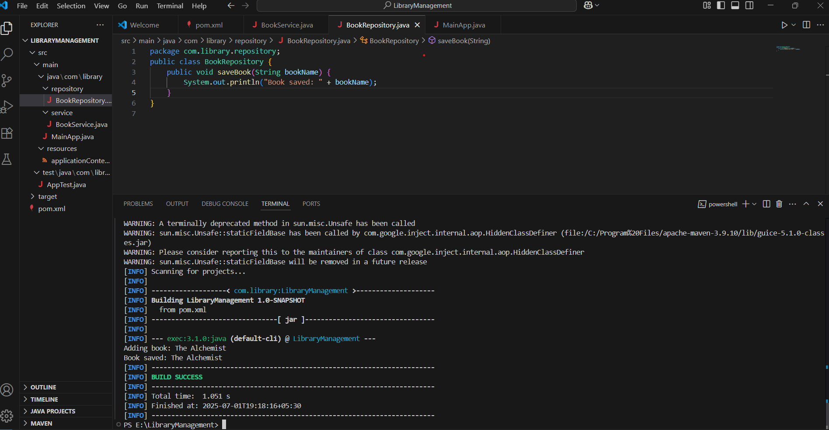

**Exercise 2: Implementing Dependency Injection**

**Scenario:**

In the library management application, you need to manage the dependencies between the BookService and BookRepository classes using Spring's IoC and DI.

**applicationContext.xml**

<?xml version="1.0" encoding="UTF-8"?>

<beans xmlns="http://www.springframework.org/schema/beans"

       xmlns:xsi="http://www.w3.org/2001/XMLSchema-instance"

       xsi:schemaLocation="

           http://www.springframework.org/schema/beans

           http://www.springframework.org/schema/beans/spring-beans.xsd">

    <bean id="bookRepository" class="com.library.repository.BookRepository"/>

    <bean id="bookService" class="com.library.service.BookService">

        <property name="bookRepository" ref="bookRepository"/>

    </bean>

</beans>

**BookService.java**

package com.library.service;

import com.library.repository.BookRepository;

public class BookService {

    private BookRepository;

    // Setter for Dependency Injection

    public void setBookRepository(BookRepository bookRepository) {

        this.bookRepository = bookRepository;

    }

    public void addBook(String title) {

        System.out.println("Adding book: " + title);

        bookRepository.saveBook(title);

    }

}

**Output:**

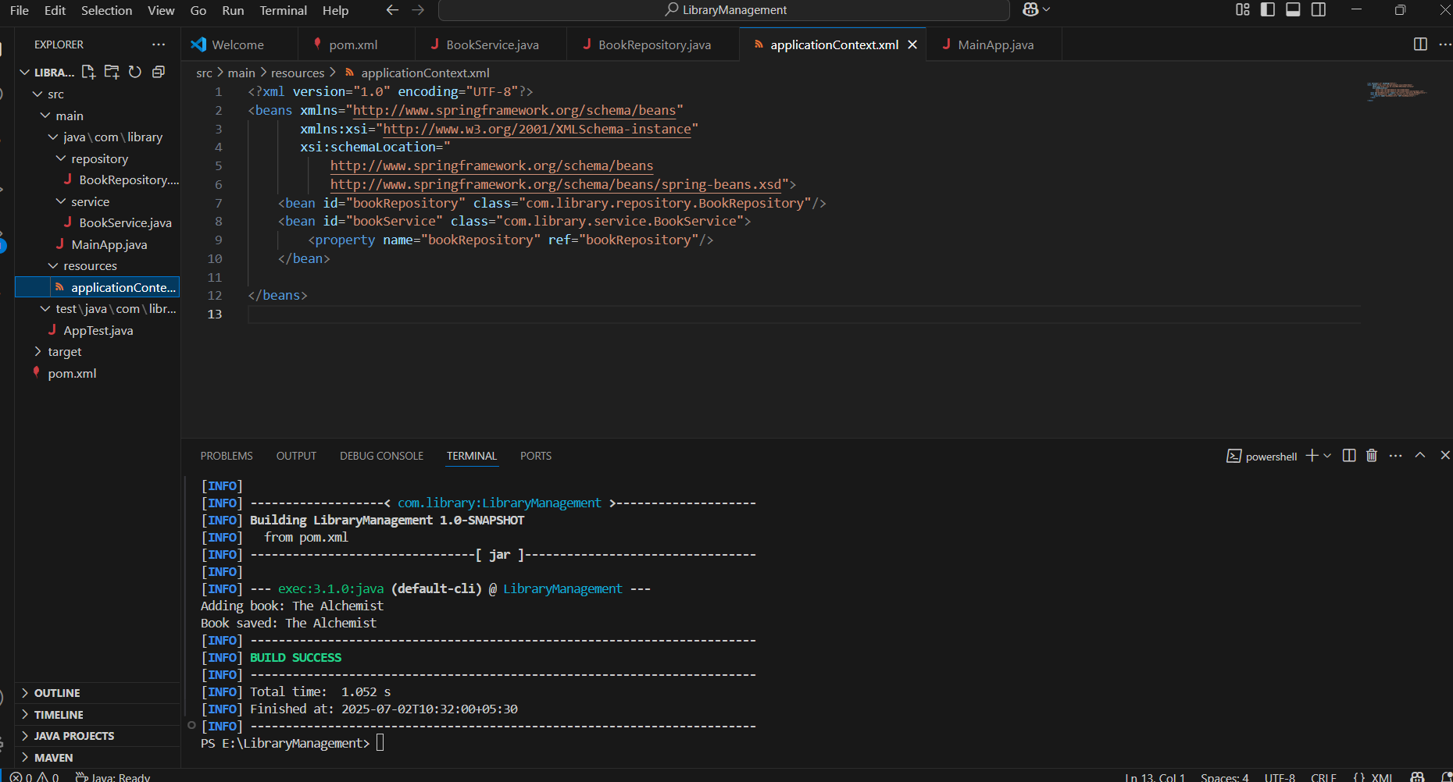

**Exercise 4: Creating and Configuring a Maven Project**

**Scenario:**

You need to set up a new Maven project for the library management application and add Spring dependencies.

**pom.xml:**

<project xmlns="http://maven.apache.org/POM/4.0.0"

         xmlns:xsi="http://www.w3.org/2001/XMLSchema-instance"

         xsi:schemaLocation="http://maven.apache.org/POM/4.0.0

                             http://maven.apache.org/xsd/maven-4.0.0.xsd">

  <modelVersion>4.0.0</modelVersion>

  <groupId>com.library</groupId>

  <artifactId>LibraryManagement</artifactId>

  <version>1.0-SNAPSHOT</version>

  <properties>

    <java.version>1.8</java.version>

  </properties>

  <dependencies>

    <!-- Spring Context -->

    <dependency>

      <groupId>org.springframework</groupId>

      <artifactId>spring-context</artifactId>

      <version>5.3.33</version>

    </dependency>

    <!-- Spring AOP -->

    <dependency>

      <groupId>org.springframework</groupId>

      <artifactId>spring-aop</artifactId>

      <version>5.3.33</version>

    </dependency>

    <!-- Spring Web MVC -->

    <dependency>

      <groupId>org.springframework</groupId>

      <artifactId>spring-webmvc</artifactId>

      <version>5.3.33</version>

    </dependency>

    <!-- JUnit 5 for testing -->

    <dependency>

      <groupId>org.junit.jupiter</groupId>

      <artifactId>junit-jupiter</artifactId>

      <version>5.9.3</version>

      <scope>test</scope>

    </dependency>

  </dependencies>

  <build>

    <plugins>

      <!-- Compiler Plugin for Java 1.8 -->

      <plugin>

        <groupId>org.apache.maven.plugins</groupId>

        <artifactId>maven-compiler-plugin</artifactId>

        <version>3.8.1</version>

        <configuration>

          <source>${java.version}</source>

          <target>${java.version}</target>

        </configuration>

      </plugin>

      <!-- Exec Plugin for running Java main class -->

      <plugin>

        <groupId>org.codehaus.mojo</groupId>

        <artifactId>exec-maven-plugin</artifactId>

        <version>3.1.0</version>

        <configuration>

          <mainClass>com.library.MainApp</mainClass>

        </configuration>

      </plugin>

    </plugins>

  </build>

</project>

**Output:**

